Last time I'm talked about the Dark Souls and the negative effects they make to the character. Now I'm giving a little more detail about the Monster's Souls. Every monster when killed will leave his soul. They will exist only for a short period of time, and after that they will disappear. So, the player needs to be quick to collect them. When the player collects 100 monsters’ souls, he/she will be able to activate a special state, which will last for a specific period of time.

For the Warrior it’s the “Anger of Warriors”. While in this state the player will acquire a special weapon: the double Greatsword. This weapon will not require any mana, and it will make very high damage which will increase with each character's strength level. In addition to this it will drain health from the killed monsters and deliver health to the character, even beyond its maximum. Also, the character’s stamina and mana will be regenerating during this state.

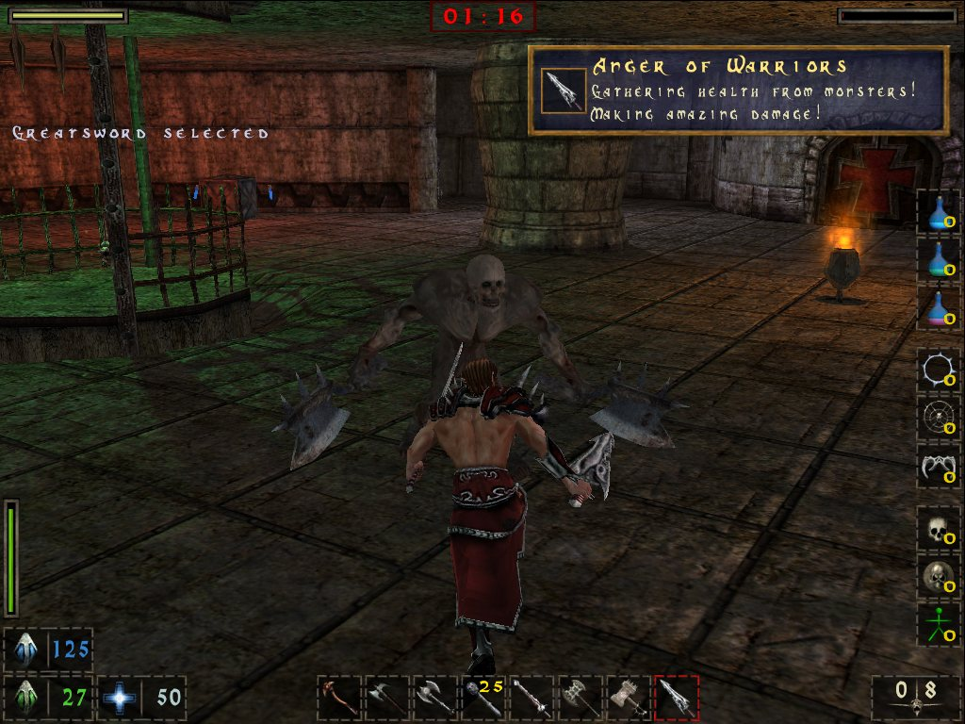
Anger of Warriors

For the Amazon this is the “Touch of Acid Bolts”. Like the Warrior, she will gain a new weapon: a Crossbow which will fire acid bolts at high rate. As one may suppose, the bolts will poison the monsters and quickly kill even the biggest monster.

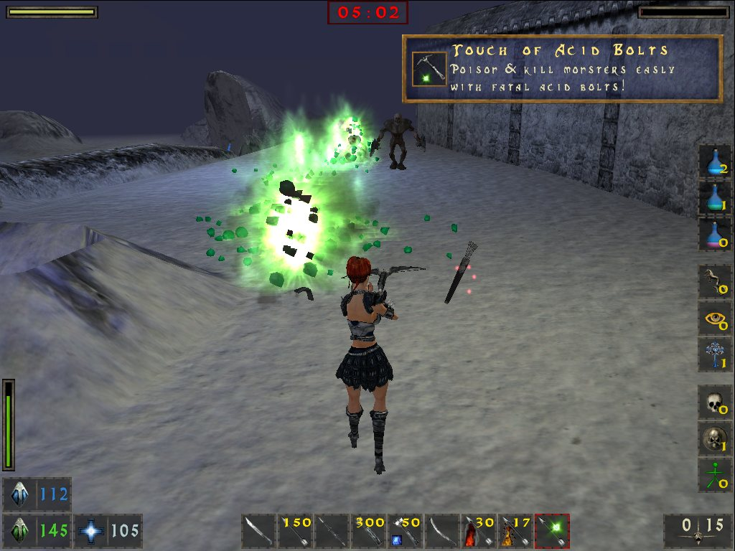
Touch of Acid Bolts

Besides the character, weapons are also gaining experience. The player will be more skilled with the weapon which he/she uses more often. During the game the AI will keep statistics for each weapon, which includes: number of uses, hits and kills. As the weapon's skill level increases, it will become stronger, thus making more damage. With weapon progression it is possible to make either enhanced, critical or fatal hits. Enhanced damages are a few hit points higher than the usual ones; critical hits – depending on the weapon are double, triple or quad! And the last: fatal hits, as the name says, will kill any monster with just one hit! The character can make fatal hits only with the weapon which has the highest skill level. Either critical or fatal hit chances are increasing with the character's strength and weapon specific skill. Also, Warrior is most likely to make such hits than the Amazon.

