Fierfek’s Mapmaking Guide

Contents:

Introduction
PART 1: Basic Modding
1. First Map Mistakes
2. Creating the Map
3. The Editor
4. Command Posts
5. Objects
6. The LUA
7. Munging
PART 2: Advanced Modding
8. Vehicles
9. Planning/Barriers
10. Localizing
11. The Sky
PART 3: What’s Next
12. Packaging
13. Playing Other People’s Maps

Introduction:

Hi, I’m Fierfek. Fierfek is a curse used by Clone Troopers. It is Huttese for poison. If you have played Republic Commando, you may have hear Sev saying things like, “Fierfek, there’s a Trando Merc.” Anyway, I have been around a lot of maps, so I know which kinds people like. So, this is everything I know about mapping.

PART 1: Basic Modding

Part 1. First Map Mistakes

This section is about first maps. I have notice a couple things that really tick people off about first maps. Here they are:

- That Yavin ground texture (this is always a sign of an amateur)
- That Yavin sky (again, anything Yavin is a sign)
- First maps are often completely flat. It doesn’t matter if that suits your map’s setting. Give the map some hills. You honestly don’t know how important this is. Flat maps suck.
- First maps are often HUGE. First mappers don’t realize that the 2 command posts they placed will take 10 minutes to walk across. I would suggest importing some Clone Trooper objects (ModID\common\sides\rep), just to make sure you’re not making the map too big.
- Don’t start with an indoor map. You might say, “But Squipple’s ‘Ancient Research Facility’ was a first map, and that was indoor!” Well, that map was exceptional. Make an outside map first. They are a lot easier.
- Don’t flood the map with water. Water requires a lot of extra programming to get working. Don’t start with water.
- Change the setup of the 4 command posts. Keeping them in that box formation is boring, and we’ve seen it a million times. Move the command posts around.
- Change the heroes. Please, no Anakin, Maul, Han, or Boba. They are the defaults, and must be changed. More on changing them later.
- Go basic. Try not to go insane with platforms going to 10 different command posts. Those maps aren’t very easy to make.

I think those are all the signs of a first map. Notify me if you see any others.

Part 2. Creating the Map

Go to Start\All Programs\Lucasarts\Star Wars Battlefront II. Open Mod Tools. Click Star Wars Battlefront Mod Tools. The Icon should look like a 3d puzzle being put together. A screen like this should come up:

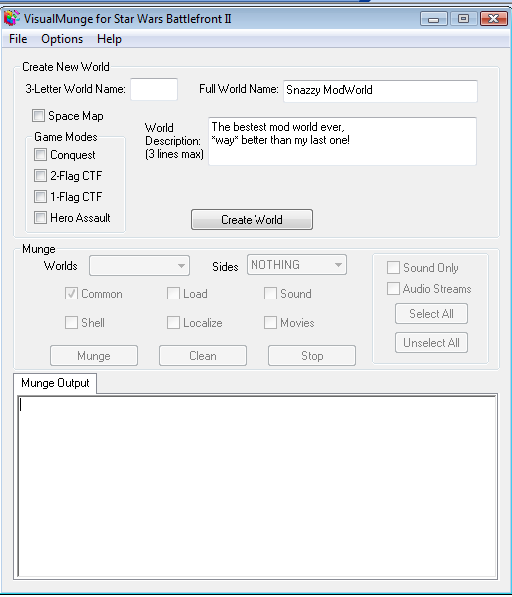
A
B
C
D
A – 3 letter world name. For our test map, let’s do MAP.

B – Your World’s Name. For our test map, let’s do “First Map” (you can change the name later)

C – Description that will show up in BF2. Write whatever you want here.

D – These are the game modes for your map. You can choose from the 4 listed, or do a space map. For our test map, let’s just check Conquest.

CLICK CREATE WORLD.

Our map will take several minutes to make. Don’t do anything else on your computer, as you will likely freeze the munger. After several minutes, a notice will come up with info about munging it.
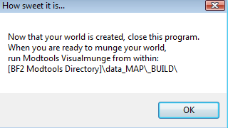
You don’t need to worry about that for now. Just hit okay. Go to your BF2_Mod Tools directory, and find the folder title “data_MAP”. Open it, and open zeroeditor. It’s icon should look like some sort of wrench. It will open, and we are into our next section.

Part 3. The Editor

This is the editor, where most of the main action will happen.
You should be at a screen like this:
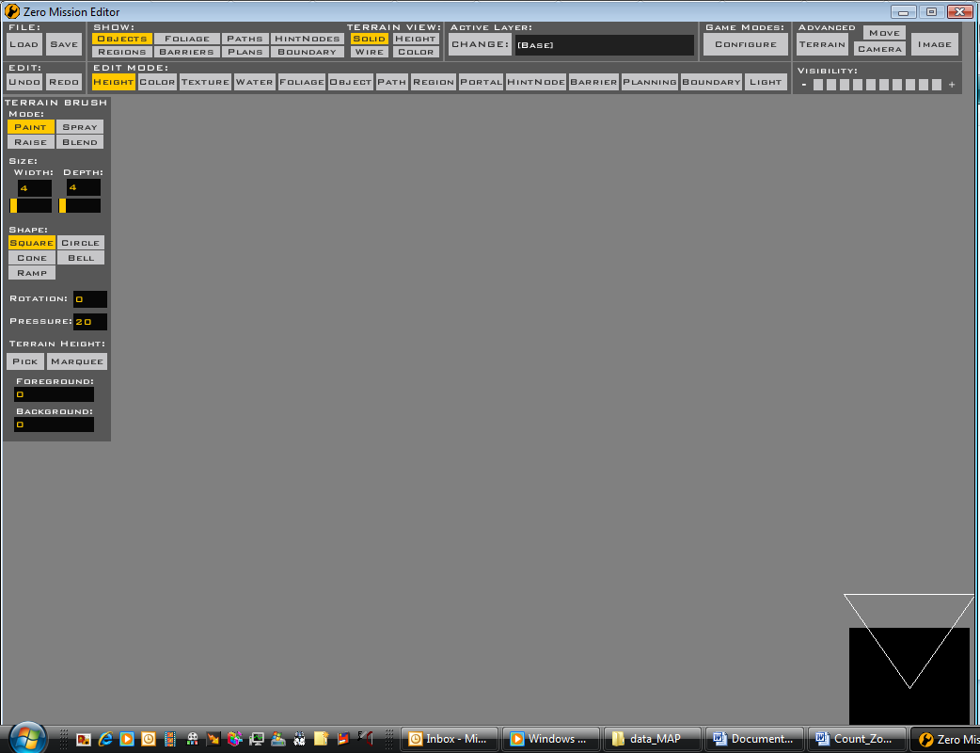
Hit Load.
Hit Load (see the screen).

Now you will be at a screen something like this:

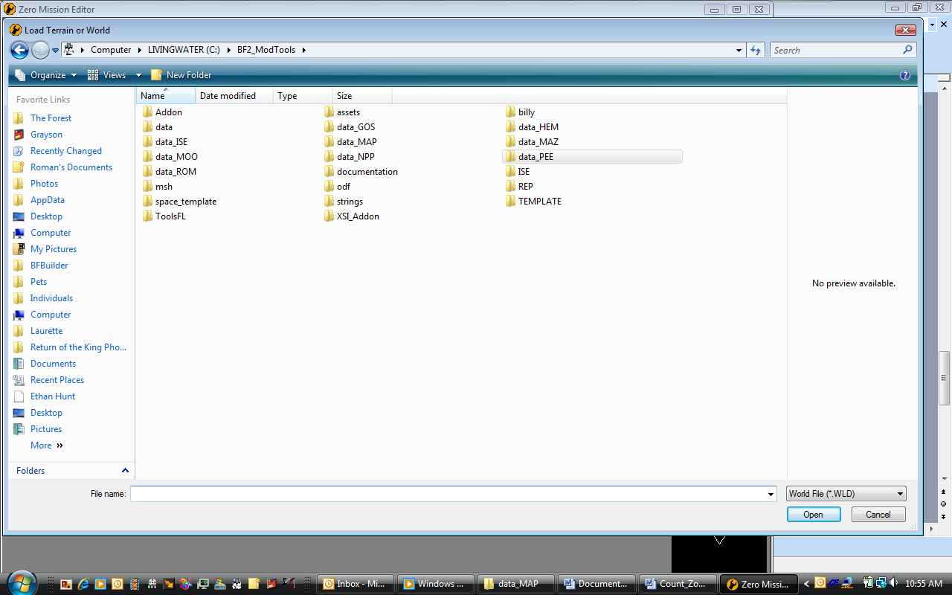

Navigate to your Mod directory (data_MAP). Go into the Worlds folder, MAP, world1. you should then be here:
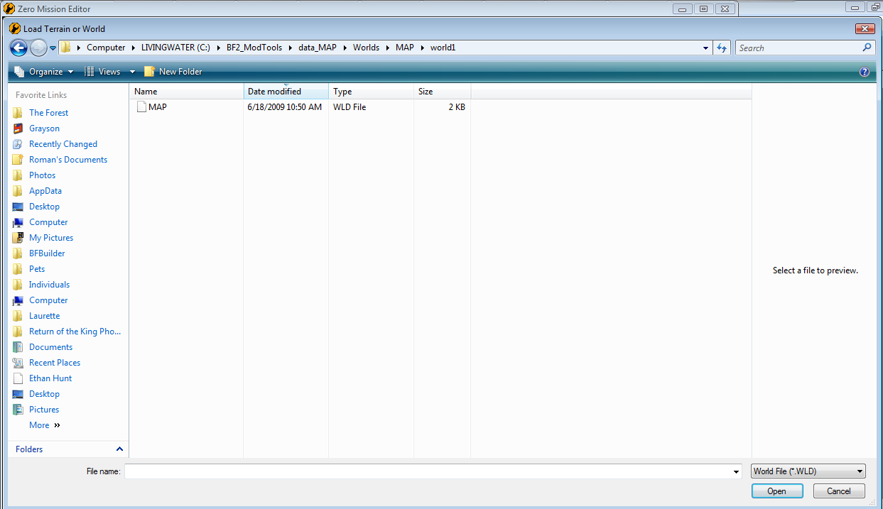
Hit MAP. This will bring up a screen like this:

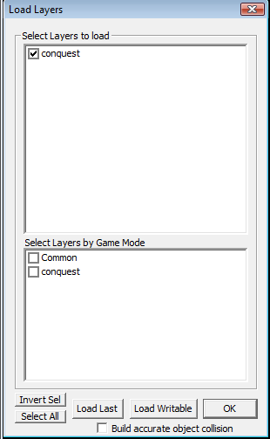

Check conquest, common, conquest, and build accurate object collision. Hit OK.
If zeroeditor freezes while opening, just leave it. After a couple moments (be patient), you will be in the editor. There are a couple of basic controls you will need for navigating the editor:

WASD: Move your view around
Tab: Enable Mouse Free-Look
Hold C: Move object/regions Left, Right, Up, and Down
Hold X: Rotate objects
Hold Left Mouse Button: Red Line Movement
Hold Right Mouse Button: Green Line Movement
Hold Mouse Wheel Down: Blue Line Movement

All right, now that we have those figured, we can continue. It doesn’t matter if you don’t understand all this. I will go into more detail later.
Move around. After moving around for a while, you will notice you are in a level like this:

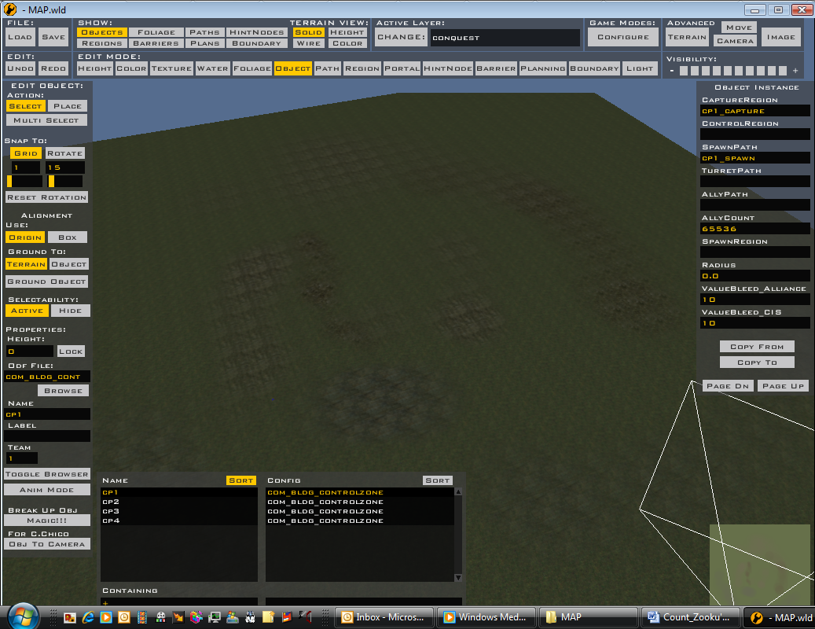

These are the hated Yavin textures. No one likes these. If you are going to make a successful map, you must change these. See the boxes outlined above? This is your selection of Edit Modes. Click texture. There will be a palette on the right like this:
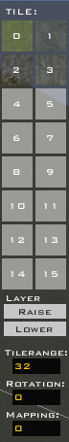

There are 16 boxes, numbered 0-15. You will notice the top 4 have colors in them. Click 0. Now there will be a palette on the left like this:
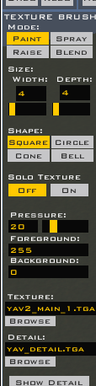

We will focus on the outlined part for now. Lets get the texture from Endor, okay? To do that, go back to your BF2_Mod Tools directory. Find the assets folder. Go to worlds, then END. Go into world1. Find end1_lowresterrain.tga. Put it in your world1 folder. Now click browse in the editor. Find the file you just put in your folder. Select it. Delete the text in the DETAIL: box. Do the same will all 4 colored boxes. If you did everything right, your map should now look like this:

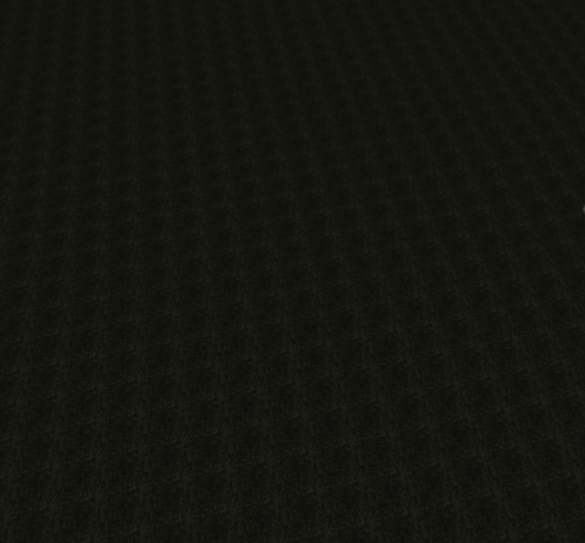
Much better. Now that the gross Yavin textures are gone, let’s save. Go to the top left, and click save. Navigate in the window to your world1 folder. Overwrite the world file there.
Now let’s explore height. Click height in the edit modes panel. Now a screen on the left will look like this:

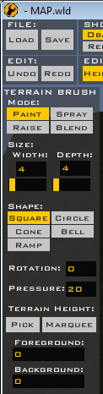

Let’s play with this now. Change width and depth to 5 each. Change MODE: to raise. Change shape to circle. Now go to a spot on your map. You will have a little green circle following your cursor. Hold down the left mouse button in one spot. The terrain will start to rise. If you hold down the right mouse button, it will start to sink. Play around with this a little. Make some hills, and some dips. FLAT MAPS SUCK. If your map is flat, you will get minus points. Play with this for a few minutes, and get used to it. These are the other features:

PAINT: When you hold the mouse button down and drag this over the ground, it will set it to the original ground level.
SPRAY: This is a slower version of paint.
BLEND: This will smooth out the terrain, so it is not made of weird sharp cuts.

Next section:

Part 4. Command Posts

This is one of the most important parts of the guide. Command posts are the main part of Star Wars Battlefront. In order to have a good map, you must have good command posts.
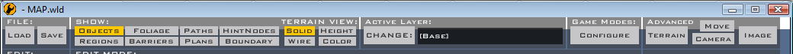

In the active layer part (outlined), click change. Another palette like this will come up:
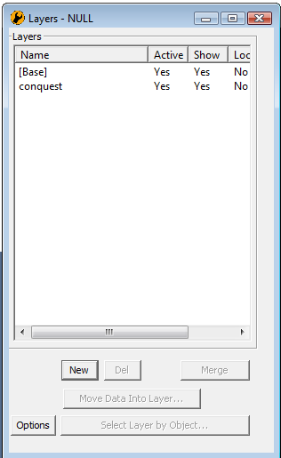

Click conquest, then exit the palette.
In the edit mode, click object. A new palette will open. The 2 important ones you want here are these ones:

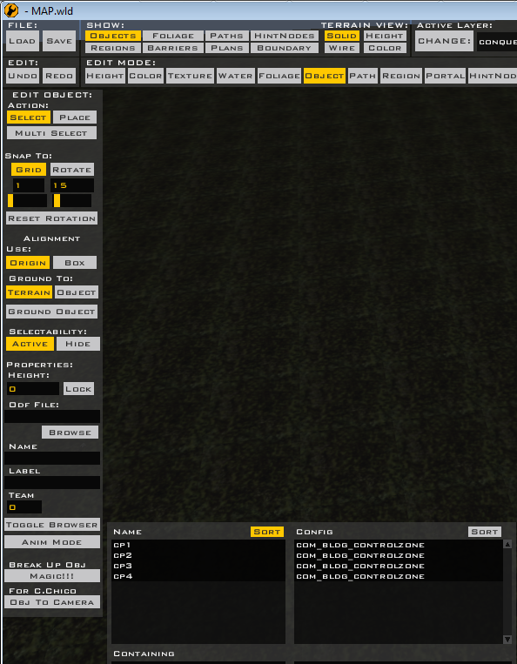

The left one is the edit object palette. The bottom one says what objects you have in your level. So far, the only objects are 4 command posts. We’ll make another command post in this step. In action, at the top of the left palette, select ‘select’. Click CP1 in the bottom palette. Now, in the left palette, click ‘place’. Before you place it, in the very top palette, next to the load/save one, is SHOW:. Make sure objects, regions, and paths are selected. You will now see some weird shapes on the maps. Zoom in on one. It looks like this:

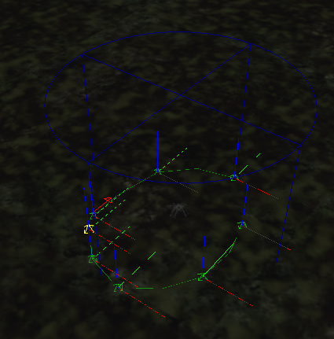

The blue cylinder is the capture region. This is the region that indicates where you must be to be able to capture the command post. If a trooper is standing within this region, the capture icon will appear, and they will start capturing the command post. The little spheres connected to each other make up the spawn path. Each of these circles represents a place where a trooper will spawn. Each of these are crucial to making a command post.
You will also notice the 4 command posts are in a box:
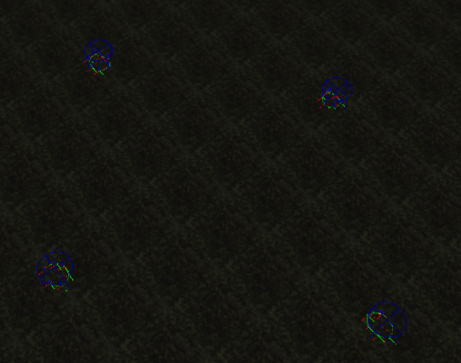

As I said before, this is a sign of being an amateur. We will now focus on moving them around. We will place the 5th command post later. Select one of the command posts. Hold down C. You will now see red, green, and blue lines across it.

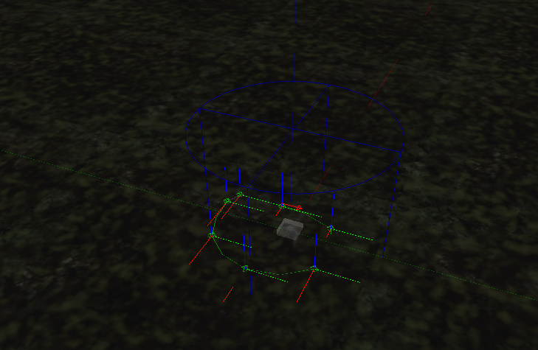

It doesn’t matter if they are not very visible. If you can’t see the red lines, that just means the command posts are grounded. Try moving the command post around. Hold down the left mouse button to move the object along the red axis. Hold down the right mouse button to move the object along the green axis. Hold down the middle mouse button to move the object up and down along the blue axis. Move the command post to a different position on the map. Now, you need to move the capture region to the command post. In edit mode, select region. Now, the palette on the left will look like this:

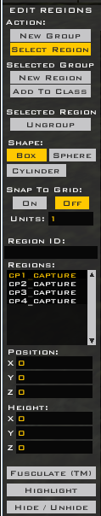

Make sure action: at the top is on Select Region. Select the region that was originally next to the command post you moved. Move it in the same manner you moved the command post. Move it over to the command post’s new position. Once you have done that, choose Path in edit mode. Now the left palette will look like this:

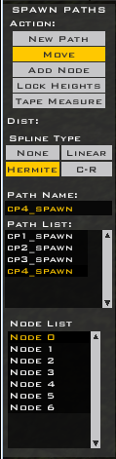

Select Move in the action part of the palette. Go to the path where the command post and region were moved from. If you hold down the left mouse button, you can move each circle one at a time. If you hold down the right mouse button, you can move the whole path at once. Move the path to the command post’s new position. Now you have moved the whole command post. Do this to all the command posts, moving them around so they don’t resemble the shape of the original box at all. Make sure they are about the same distance to each other though. BIG MAPS SUCK. Now, let’s add another command post. Go back to objects in Edit Mode. Select CP1, and then select place in Action. Place the command post close to the other 4. Now, you must set the command post’s properties. At the bottom of the left palette, you will see this:

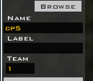

Write CP5 in Label. Set team to 0. 0 is neutral, 1 is Republic/Empire, 2 is CIS/Rebels, 3 is locals. Now go to the right palette. You will see these fields:

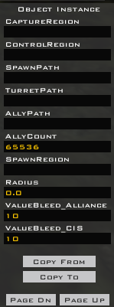

In CaptureRegion, type cp5_capture. In SpawnPath, type cp5_spawn. Now, you must make the capture region for this new command post. Choose region from edit mode, and select New Group. Select cylinder. Now click near the command post. A huge cylinder will be over it. Select ‘select region’. Now, click the new region.

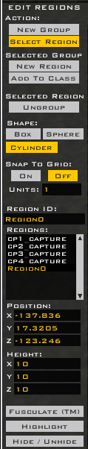

In the left palette, in region ID, it says region0. Change that to cp5_capture. Now, above, to the right, you will se another palette.

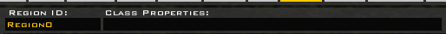

Change both of these to cp5_capture. Now, in height (back in the left panel), set X, Y, and Z to 5 each. Now, hold C and use the middle mouse button to lower it to go into the ground. Make sure it looks like this:
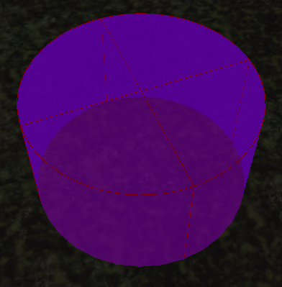
Now, you need to make the spawn path. Go to Path in edit mode. The left palette will look like this:

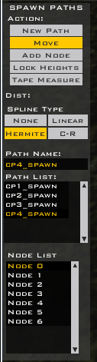

Press new path. A new path will come up in Path List, named Path 4. In Path Name, rename it cp5_spawn. Now, click about 6 or 7 times around your command post. Spheres will appear. This is the spawn path. Now, you have created another command post. There is only one step left to finishing the command post, which will be explained later, in Part 6. Now that you have made another neutral command post, you understand how to make command posts. One last thing about paths: to change their height, hold down shift and the right mouse button. This will allow you to slide the path up and down.
The next section will teach you to handle objects in Zeroeditor.

Part 5. Objects

In order to have a good map, you must have objects in it. There is not one map in Star Wars Battlefront that does not have objects in it. Objects are very important, and you will now learn how to insert them.
First, choose the world you want objects from. Since we have Endor terrain, let’s do Endor. In the assets folder, find worlds and END again. This time, highlight ODF and MSH. Copy them to your world1 folder. Now, in the Zeroeditor, select objects from Edit Mode. The Left Palette looks like this:

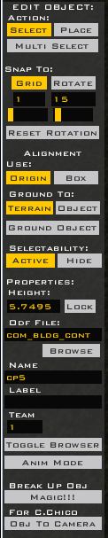

Click Browse. Find your world1 folder, and enter the odf folder. Wow, that’s a lot of files! Each of these files is an object from Endor. Let’s say we want one of the command posts to be behind some trees. Find end_prop_leaftree. Click it. Now, in the palette, make sure Place is selected at the top. Now, place some tress around the 5th command post. This is very basic. You can browse for other objects, and insert anything you want. You could insert the odf and msh folders from any world, and place whatever you want in your world. Using Multi-Select, you can select multiple items at once, and copy/paste. Play around with the objects. They are really what make the level. A couple pointers:

- Make sure they are not floating
- Make sure you are not making it obscure. Having a bunker in the middle of nowhere doesn’t really fit. Neither does 10 techno union ships stacked on top of each other.
- Use crates/barrels and the such. They help with cover during a battle.

Part 6: The LUA File

For now, we are done with Zeroeditor. Now, we will take a look at the script. In this part, we will change the heroes for our level, and do the last step for adding command posts.
Go to data_MAP. Now, enter the common folder. Then go scripts\MAP. You should see 9 files. We want 4 of them:

MAPc_con
MAPc_con.lua
MAPg_con
MAPg_con.lua

The ones that start with MAPc are for the clone wars. The MAPg ones are for the galactic civil war. We will start with the command post. Open MAPc_con with Notepad. Office Word will not work here, it must some sort of Notepad. You will see a screen like this:

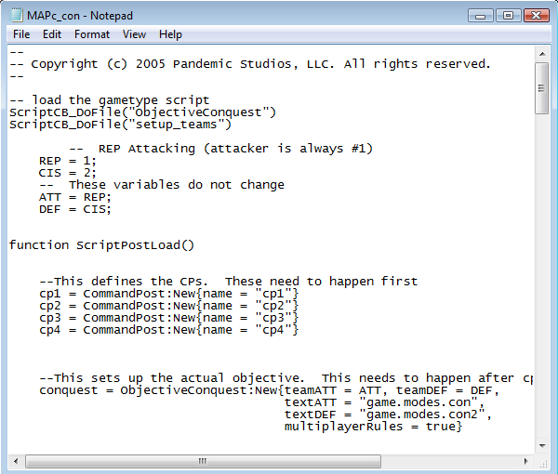

This is the LUA file. This is what makes the game work. There are 2 parts we need to change. The first is this:

--This defines the CPs. These need to happen first
cp1 = CommandPost:New{name = "cp1"}
cp2 = CommandPost:New{name = "cp2"}
cp3 = CommandPost:New{name = "cp3"}
cp4 = CommandPost:New{name = "cp4"}

Here, you need to add one more line. Copy the last line, so now you have this.

--This defines the CPs. These need to happen first
cp1 = CommandPost:New{name = "cp1"}
cp2 = CommandPost:New{name = "cp2"}
cp3 = CommandPost:New{name = "cp3"}
cp4 = CommandPost:New{name = "cp4"}
cp4 = CommandPost:New{name = "cp4"}

In the last line, change the cp4’s to cp5. So now, you end up with this:

--This defines the CPs. These need to happen first
cp1 = CommandPost:New{name = "cp1"}
cp2 = CommandPost:New{name = "cp2"}
cp3 = CommandPost:New{name = "cp3"}
cp4 = CommandPost:New{name = "cp4"}
cp5 = CommandPost:New{name = "cp5"}

This tells the game how many command posts are there. You need to do this in all 4 files listed. There is one other part. Scroll down until you find:

--This adds the CPs to the objective. This needs to happen after the objective is set up
conquest:AddCommandPost(cp1)
conquest:AddCommandPost(cp2)
conquest:AddCommandPost(cp3)
conquest:AddCommandPost(cp4)

This adds the command posts to the objective, so that you need to capture all of them to win. As in the last one, copy the last line, and change to cp5. This is what you end up with:

--This adds the CPs to the objective. This needs to happen after the objective is set up
conquest:AddCommandPost(cp1)
conquest:AddCommandPost(cp2)
conquest:AddCommandPost(cp3)
conquest:AddCommandPost(cp4)
conquest:AddCommandPost(cp5)

Now your command post is added. Make these changes to all 4 of the files listed before.
Now we will change the heroes. These are who we will change them to:

Anakin → Mace Windu
Darth Maul → Jango Fett
Han Solo → Chewbacca
Boba Fett → Darth Vader

Now, go to assets. We need to find the coded names of these heroes. Go into the sides folder, then to rep, then odf. Here are all the republic files. Sort by name, and find the section where everything is sorted by rep_hero_(hero name). The default is rep_hero_anakin. We want Mace Windu. So scroll down until you find him. He is rep_hero_macewindu. Write that down somewhere. Now, let’s find Jango Fett. Go to the cis folder this time, and the odf folder. Find cis_hero_jangofett. Write that down too. Now, for the all folder. Find all_hero_chewbacca. Write that down too. Last, but not least, the imp folder. Find imp_hero_darthvader. So, these are the coded names of the heroes we want:

Rep_hero_macewindu
Cis_hero_jangofett
All_hero_chewbacca
Imp_hero_darthvader

Pretty simple, huh? Okay, back to the script files (ModID\common\scripts\ModID). Enter MAPc_con again. Now, go down to this text:

ReadDataFile("SIDE\\rep.lvl",
"rep_inf_ep3_rifleman",
"rep_inf_ep3_rocketeer",
"rep_inf_ep3_engineer",
"rep_inf_ep3_sniper",
"rep_inf_ep3_officer",
"rep_inf_ep3_jettrooper",
"rep_hover_fightertank",
"rep_hero_anakin",
"rep_hover_barcspeeder")
ReadDataFile("SIDE\\cis.lvl",
"cis_inf_rifleman",
"cis_inf_rocketeer",
"cis_inf_engineer",
"cis_inf_sniper",
"cis_inf_officer",
"cis_inf_droideka",
"cis_hero_darthmaul",
"cis_hover_aat")

This tells the level which files to go get for the game. As you can see, it has loaded the units for battle, as well as some vehicles, and the heroes. But here, it says ‘rep_hero_anakin’ and ‘cis_hero_darthmaul’. These aren’t the heroes we want. So, enter your heroes in. Now, it should look like this:
ReadDataFile("SIDE\\rep.lvl",
"rep_inf_ep3_rifleman",
"rep_inf_ep3_rocketeer",
"rep_inf_ep3_engineer",
"rep_inf_ep3_sniper",
"rep_inf_ep3_officer",
"rep_inf_ep3_jettrooper",
"rep_hover_fightertank",
"rep_hero_macewindu",
"rep_hover_barcspeeder")
ReadDataFile("SIDE\\cis.lvl",
"cis_inf_rifleman",
"cis_inf_rocketeer",
"cis_inf_engineer",
"cis_inf_sniper",
"cis_inf_officer",
"cis_inf_droideka",
"cis_hero_jangofett",
"cis_hover_aat")

See? Now, it tells the game to load those heroes. Scroll down to:

SetHeroClass(CIS, "cis_hero_darthmaul")
SetHeroClass(REP, "rep_hero_anakin")

This tells the game who to set the heroes to. Change these to our ones, so it says:

SetHeroClass(CIS, "cis_hero_jangofett")
SetHeroClass(REP, "rep_hero_macewindu")

Now, this file is ready. Do the same to MAPc_con.lua. Now, onto the Galactic Civil War Ones. Do the same, except instead of changing the heroes to mace windu and jango fett, change them to Chewbacca and darth vader. Everything is the same, except you are changing from boba fett and han solo instead of Anakin and maul.

Once you have done this, we are done with LUA’s for now. I will not go into more advanced LUA work in this guide, but LUA’s allow you to make custom sides, add objectives to missions, and other cool things.

Part 7: Munging

Now I will tell you how to munge. Go to your mod directory, then _BUILD. Click Modtools VisualMunge. Now you will have a screen like this:

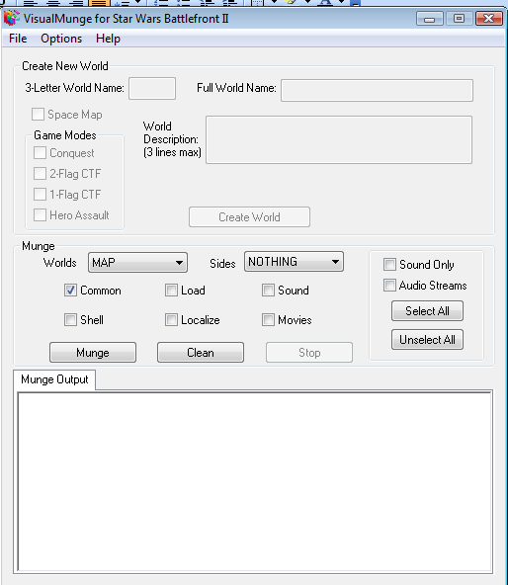

At the right, click Select All. Now, click Munge. Wait several minutes for it to be done munging. Then, a notice like this will come up:

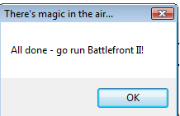

A Notepad will also come up, telling you the errors. You can just exit that. Click OK, then you can go run Battlefront II. Your level is in the selection screen!! Now you can play your level you made! Have fun modding!!
PART 2: Advanced Modding

Part 8. Vehicles

Okay, so you made your map, and are having fun playing it in BF2. But you want to have some way to get around your map besides walking. I don’t blame you, I would too. So, in this section, I will teach you to add in vehicles, and we will add in some speeders.
First, we need to figure out the coded names of the speeders. Go to each side folder, but instead of going into odf, open the req file (the one without shell on the end). There is a list of vehicle codenames. The ones we want here are:

Rep_hover_barcspeeder
Cis_hover_stap
Imp_hover_speederbike
(the rebels don’t have their own speeder, so they use the imperial one)

Okay, open up zeroeditor. Make sure you are in the conquest layer. Now, in objects, click browse. Go to ModID\common\odfs. Find com_item_vehicle_spawn. You will also need to create control zones for your command posts. Control zones are made exactly the same way as capture zones, except for a few differences:

- Control Zones are not written as cp#_capture, but cp#_control
- Control Zones are squares, not cylinders
- Control Zones should be 10 height instead of 5
- Control Zones should be placed next to the command posts instead of over them

Edit the command posts so that the palettes look something like this:

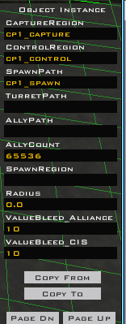

Then, make the control regions. Place them next to the command posts. Now we will make vehicles.
Go back to objects, and find com_item_vehicle_spawn again. Place 2 or 3 next to each command post, outside the capture zone but NOT IN THE CONTROL ZONE. This is important. Do not place the vehicle spawns in the control zones. The right palette will look like this:

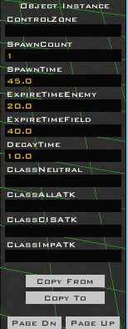

Now here it gets a bit repetitive. In ControlZone, write the command post number. So, if it is cp1, write cp1, if cp2 write cp2, etc. In Spawn Count, put 1. In Spawn time, put 30.0. In ExpireTimeEnemy, put 30.0. In ExpireTimeField, put 60.0. In DecayTime, put 30.0. Now, you need to specify what class of vehicle you are putting in. Each field (find more by pressing page dn) specifies a kind of vehicle. The ones you need to fill in are:

ClassAllATK
ClassCISATK
ClassImpATK
ClassRepATK
ClassAllDef
ClassCISDef
ClassImpDef
ClassRepDef

Now, each of these is for a side. So, for the All and Imp ones, type:

Imp_hover_speederbike

For Each of the Rep ones, type:

Rep_hover_barcspeeder

And For Each of the CIS ones, type:

Cis_hover_stap

Easy? Yeah, but you have to do that for every single vehicle spawner. It gets really tiring. You can do different vehicles kinds as well. Look through all the vehicle types in the side folder and req files. There are many different varieties.
Before the vehicles will work, we need to edit the LUA files again. Go to common\scripts\MAP. You need the same 4 we worked with before. Open MAPc_con. Find the text:

ReadDataFile("SIDE\\rep.lvl",
"rep_inf_ep3_rifleman",
"rep_inf_ep3_rocketeer",
"rep_inf_ep3_engineer",
"rep_inf_ep3_sniper",
"rep_inf_ep3_officer",
"rep_inf_ep3_jettrooper",
"rep_hover_fightertank",
"rep_hero_anakin",
"rep_hover_barcspeeder")
ReadDataFile("SIDE\\cis.lvl",
"cis_inf_rifleman",
"cis_inf_rocketeer",
"cis_inf_engineer",
"cis_inf_sniper",
"cis_inf_officer",
"cis_inf_droideka",
"cis_hero_darthmaul",
"cis_hover_aat")

Now, remember, these tell the game what files to read. So, now we need to input our vehicles. Edit it so it looks like this:

ReadDataFile("SIDE\\rep.lvl",
"rep_inf_ep3_rifleman",
"rep_inf_ep3_rocketeer",
"rep_inf_ep3_engineer",
"rep_inf_ep3_sniper",
"rep_inf_ep3_officer",
"rep_inf_ep3_jettrooper",
"rep_hover_fightertank",
"rep_hero_anakin",
"rep_hover_barcspeeder")
ReadDataFile("SIDE\\cis.lvl",
"cis_inf_rifleman",
"cis_inf_rocketeer",
"cis_inf_engineer",
"cis_inf_sniper",
"cis_inf_officer",
"cis_inf_droideka",
"cis_hero_darthmaul",
"cis_hover_aat",
“cis_hover_stap” )

See? We added cis_hover_stap. Now the game knows to read that file. Do the same to MAPc_con.lua. Now, onto the GCW files. Open MAPg_con. Find the text:

ReadDataFile("SIDE\\imp.lvl",
"imp_inf_rifleman",
"imp_inf_rocketeer",
"imp_inf_engineer",
"imp_inf_sniper",
"imp_inf_officer",
"imp_inf_dark_trooper",
"imp_hero_bobafett",
"imp_fly_destroyer_dome" )

Remember, no Rebel files need to be read, because they are borrowing the Imperial’s speeder. Edit it so it says:

ReadDataFile("SIDE\\imp.lvl",
"imp_inf_rifleman",
"imp_inf_rocketeer",
"imp_inf_engineer",
"imp_inf_sniper",
"imp_inf_officer",
"imp_inf_dark_trooper",
"imp_hero_bobafett",
"imp_fly_destroyer_dome",
“imp_hover_speederbike” )

See? We added imp_hover_speederbike. Get used to fiddling with these LUA files. Do the same to MAPg_con.lua. Now, vehicles should spawn in your map. The next section will teach you to make the AI smarter, so they know where to walk.

Part 9. Planning/Barriers

This is probably one of the most boring parts of making a map, but one of the most crucial. No one likes it when the AI just stand around in a circle, and don’t do anything. So, sadly, this step is neccasary.
In Zeroeditor, pick planning from Edit Mode. The Palette looks like this:

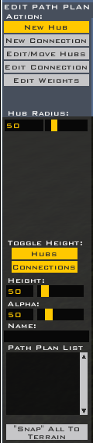

First, let me tell you about this. You basically put down hubs on the ground, and connect them to each other with connections. The AI then walk along these paths. Simple, but this can be tricky. To place hubs, click new hub, and click on the ground. Drag to choose the size. Make tons of these. They are the points which the AI try to get to. Then, click new connection. Click on a hub. A line starts coming from it. Drag the line to another hub, and click the second hub. The line connects. Make lines connecting all the hubs. This will take a while to perfect, but as I said, it is crucial.
Okay, now that that is done, let’s do barriers. This is even less fun that planning. Click barriers from edit mode. This is the palette:

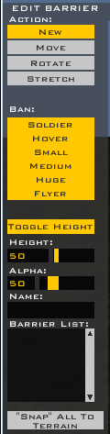

Barriers basically tell AI “Don’t touch this!” You surround objects like crates or trees with them, so that the AI don’t run into them. Click on the ground, and drag the red line to choose the width. Then, drag again to choose final size. Surround all your objects that are in the way with these. Tiring, yes, but necessary.
The next section is pretty much just for fun, but you should try it out.

Part 10. Localizing

This is the step where you can change the name of your map, change people’s names, change weapon’s names, and change messages that are displayed. Go to data_MAP. Click the batch file editlocalize. After a few seconds, and screen like this comes up:

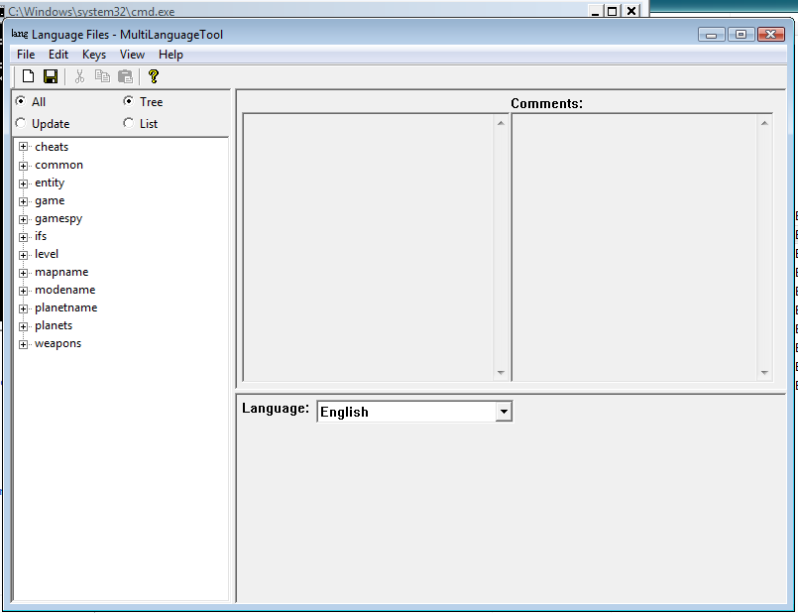

Common\Sides lets you change the names of the troopers fighting in the army. There are tons of things you can customize in here. Have fun! Note: Saving in this can take a long time, so be patient.

Part 11. The Sky

The Sky is an important thing in a level. The Yavin sky always ticks people off, so here I will tell you how to change the sky. We’ll do Endor.
Go to assets\worlds\END\world1. Find the file end1.sky, and copy to your world1 folder. Then open the end1.sky file in notepad. Scroll down to find this:

DomeInfo()
{

After this the file lists all the texture files it needs to make the sky work. They are all something like blank_blank_blank. These are the ones listed here:

sky_endor.tga
end1_sky_dome
end_sky_dome_sat
end_sky_dome_trees
end_sky_dome_death
end1_lowresterrain

So, go find these files in world1 (assets\worlds\end\world1). Copy them to your world1 folder. One last thing: we need to make the switchover. The game will read the file named MAP.sky. So, rename the old MAP.sky to old.sky. Now, rename end1.sky to MAP.sky. Now, your sky has made the switchover. Munge, and play!

PART 3: What’s Next

Part 12. Packaging

After you have tested your level thoroughly, and played around with it in zeroeditor, you can share it. Testing is extremely important. Check out Count_Zooku’s latest projects to see what happens when you don’t test levels. Check out the file Planet Onmanjon.
Now, you have a great level, and you want to share it with the world. Well, that is easily accomplished.
First, make a folder called the 3 initials you chose for your file (in our case, MAP). In that folder, make a folder called data. In that folder, make a folder called _lvl_pc. In that folder (lots of folders!) make a folder called your 3 initials again (MAP for us). Now, the first file you need in put in the first MAP folder, next to data. Go into data_MAP, and into the addme folder, then the munged folder. Get the file there, and copy to the new folder. Now, in the _lvl_pc folder. In data_MAP, go to the folder _lvl_pc. Get the files core and mission. Copy those to your new _lvl_pc. Now, for the last one. In data_MAP\_lvl_pc, go into the MAP folder. Get the one file there, and put that in your new MAP folder. So in the end, you should have this:

A folder called MAP
In that folder, a file called addme, and a folder called data
In the data folder, a folder called _lvl_pc
In that folder, 2 files called core and mission, and a folder MAP
In the MAP folder, and file called MAP

Now, find some way to zip your file up to compress it. It is now ready to go! Now you can publish it!! Go to Filefront.com, and scroll down the left side until you see the link “submit files”. Follow the instructions, and upload your file. Have fun modding!!

Part 13. Playing Other People’s Maps

I have noticed that a lot of people on Filefront have no clue how to play other people’s downloaded maps. Here is how:
1. Download the Patch from Lucasarts.
2. Go to your game folder. Enter gamedata. Make a new folder in gamedata called addon. Stick all of the downloaded maps in here. Extract them so that the folder with the 3 initials is in the folder addon. So, it would look like this:
Star Wars Battlefront II\gamedata\addon\MAP

Get it? Okay good.

Credits:

Lucasarts for Making BF2 and The Modding Tools
Me for writing the guide
All the Great Modders of Filefront from whom I learned to mod

Thanks! Make sure to give credit to me when you publish your mod! Seriously, if you read this, then I taught you to mod, and you should thank me.

Kandosii, burcya!

